**Manual Testing Assessment**

**Q1**|[Mark 20] You have a shoe-selling e-commerce platform. Now, the client wants to implement a new feature "Search". During the client meeting, they mentioned they wanted to make the search dynamic, with any keywords, or specific text. Now you have a chance to get into more details on the feature. You can ask 10 questions to the client. List the questions according to priority.

**Answer:** To gather detailed requirements for implementing a dynamic search feature, given below 10 prioritized questions-

1. **What types of data should be searchable?**

(Example: Specific Product Names, Descriptions, Categories, Brand Names, Sizes, Colors, Price Ranges.)

1. **How should the search results be ranked or prioritized?**

(Example: Newest Arrivals, Best-selling, Relevance, Popularity, Price.)

1. **Do you require autocomplete suggestions as customers type their query?**

(Type of Suggestions: Products, Categories, Keywords, etc.)

1. **Should the search support filtering and sorting options?**

(Filter by size, brand, price range, and Sort by price, popularity, ratings.)

1. **Will the search need to support advanced features like fuzzy matching or typo tolerance?**

(Example: Showing results even when customers misspell keywords.)

1. **Do you require the ability for customers to search with multiple keywords simultaneously?**

(Example: “Blue Shirt size 20 under 500 Tk.”)

1. **Should the search functionality include multilingual support?**

(If your audience speaks multiple languages, is this a requirement?)

1. **Do you need analytics for tracking customer search behavior?**

(Customers frequently searching for, most clicked results, and searches with no results.)

1. **The search feature be optimized for specific devices?**

(Note: Can you be distinct behavior for mobile versus desktop interfaces.)

1. **Do you anticipate scalability needs in the future?**

(Note: Should the search system handle large data sets, high traffic, or incorporate AI recommendations?)

**Q2|[Mark 20] Write down the test cases according to your questions.**

**Answer:** Based on my questions, I have written the test cases below:

**Test Cases for Dynamic Search Feature**

| **Test Case No.** | **Test Case Category** | **Test Case Scenario** |
| --- | --- | --- |
| **01** | **Searchable Data** | **Search for product names** |
|  |  | **Search by product descriptions and categories** |
|  |  | **Search functionality for brands, sizes, colors, and price ranges.** |
| **02** | **Ranking and Prioritization** | **Search results are displayed based on relevance to the entered keyword** |
|  |  | **Results can be sorted by popularity, newest arrivals, or price as specified** |
| **03** | **Autocomplete Suggestions** | **Search suggestions are displayed as the customer types** |
|  |  |
| **04** | **Filtering and Sorting** | **Search results based on specific criteria** |
|  |  | **Sort results** |
| **05** | **Fuzzy Matching and Typo Tolerance** | **Relevant results even if the customer enters misspelled keywords** |
|  |  | **Search supports partial matches or similar keyword variations.** |
| **06** | **Multi-Keyword Support** | **Search using multiple keywords.** |
| **07** | **Multilingual Support** | **Search supports queries in multiple languages.** |
| **08** | **Search Analytics** | **Check the frequently searched terms.** |
|  |  | **Check the capture searches yielding no results.** |
|  |  | **Customers behavior trends, like most clicked results.** |
| **09** | **Device Optimization** | **Search feature works seamlessly on both desktop and mobile devices** |
|  |  | **Check the UI/UX adapts responsively to smaller screens for mobile devices.** |
| **10** | **Scalability** | **Search can manage an expanding product catalog efficiently.** |
|  |  |  |
|  |  |  |

Q3|[Mark 20] Let's say, your development team implemented the feature on the Evershop site (https://demo.evershop.io/). Now execute your test case into the URL and generate a report.

**Answer:** [**https://docs.google.com/spreadsheets/d/1s19kz4YA757iEGExhsNvI_WdptaXy1ld4grvgby5Q4I/edit?usp=sharing**](https://docs.google.com/spreadsheets/d/1s19kz4YA757iEGExhsNvI_WdptaXy1ld4grvgby5Q4I/edit?usp=sharing)

Q4|[Mark 40] Now there is a happy path journey for searching with the text “Nike react phantom run flyknit 2”. Add a couple of small-sized black products to your cart. Then verify the Cart. Now execute the journeys from both API and UI. Now provide feedback on your test analysis, keep logs of the defects, and generate a report.

Answer: The search functionality, product selection, cart addition, and verification work correctly on both API and UI.

**UI Test:**

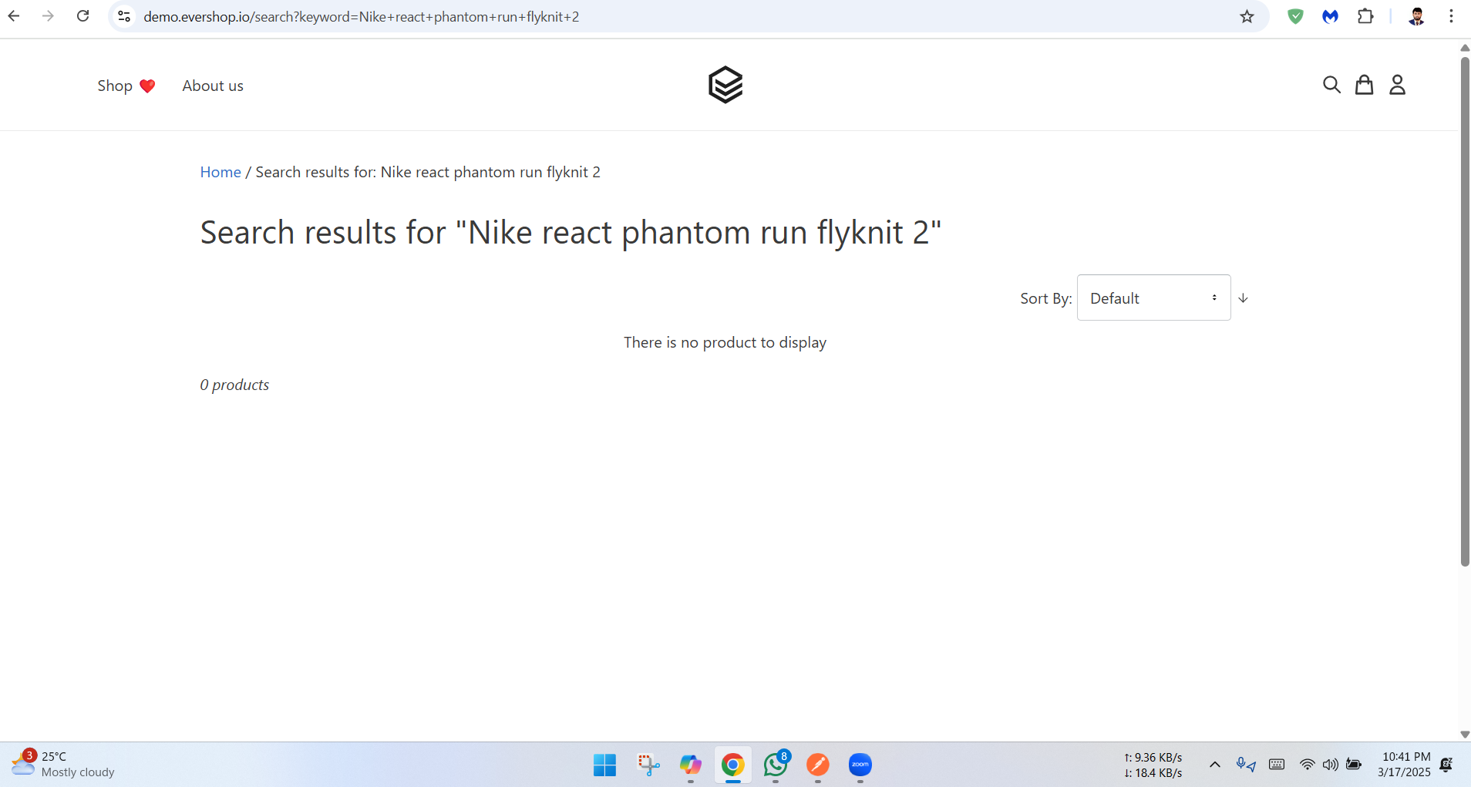

**Analysis:** Shoes of this name "Nike react phantom run flyknit 2" is not appearing on the page for UI related problem .But, In the API test product was there to show.

**API Testing:** Attachment